

Aditya Birla Grasim – GRN creation and processing

PROCESS DESIGN DOCUMENT



July 1, 2019

Prepared by: Hareharan KM

Version No: 1.0

Table of Contents

About This Document 2

1 Overview 3

1.1 Current Process Stats (AS-IS snapshot) 3

1.2 AS-IS Process flow diagram 5

2 To Be Business Process Flow 16

2.1. Scope 16

2.1.1 Activities in scope 16

2.1.2 Activities out of scope 16

2.2 To Be process flow diagram 16

2.2.1 Input Design and Process Stages 17

File formats and Templates for Developer Reference 17

2.2.2 Standardization in current process (if any) 17

2.2.3 Output Design, Logs and Archive 17

2.2.4 Exception scenarios handling 18

2.2.5 Process Breaks and Restarts 18

2.2.6 In scope application details 18

3. Solution Design – Technical Details 18

3.1 Prerequisites for Development 19

3.2 Project Files (Workflows specific to project name) 19

3.3. Development 19

3.3.1 Screenshots for development (Key stroke level) 19

3.3.2 Infrastructure/Access for environments 19

# About This Document

The Process Design Document describes in detail the business processes chosen for automation and the design approach for the software robot being developed using the approved Robotic Process Automation (RPA) Tool.

The document describes the sequence of steps performed as part of the process, the conditions, rules & exceptions of the process prior to and after automation. This design document serves as a base documentation for developers to understand the details required for robotic automation of the same business process.

Intended Audience

* *Finance Department users.*
* *Stores users.*
* *Gate 01.*

This section records the history of *significant* changes to this document. Only the most significant changes are described here. Where significant changes are made to this document, the version number will be incremented by 1.0. Minor changes made for clarity and reading purposes, where no change is made to the meaning or intention of this document, will be indicated by a 0.1 increase in the version number.

|  |  |  |  |
| --- | --- | --- | --- |
| Version | Version Date | Revision Comments | Author |
| 1.0 | 01 Jul 2019 | Initial Draft | Hareharan KM |
|  |  |  |  |
|  |  |  |  |

Reviews and Approvals

Revisions of this document are reviewed and approved by the job roles identified below.

|  |  |  |  |
| --- | --- | --- | --- |
| Name | Title | Date | Role |
| Sriram |  |  | Reviewer |
|  |  |  | Reviewer |
|  |  |  | Approval |
|  |  |  | Approval |

# 1 Overview

Aim of this RPA automation is to perform GRN Creation and Invoice validation for Sulphur, Caustic soda and Steam Coal.

GRN creation business case is mainly intended to:

➢ Deliver faster processing

➢ Reduce redundant activities performed in the current process

➢ Improve overall integrity on the data created and data being manipulated.

Business Requirement Document Reference: 

## Current Process Stats (AS-IS snapshot)

|  |  |
| --- | --- |
| **Function** | GRN Creation and Invoice validation. |
| **Department** | Inward department users  Stores department users  Finance department users |
| **Process short description**  (operation, activity, outcome) | perform GRN creation and Invoice verification for Sulphur, Caustic soda and Steam Coal |
| **Role required for performing the process** | Access to SAP system |
| **Process schedule** | Daily / Adhoc |
| **# of items processed /month** | TBD |
| **Average handling time per item** | TBD |
| **Peak period (s)** | TBD |
| **# of FTEs supporting this activity** |  |
| **Exception rate (%)** | TBD |
| **Input data** | - Data extracted from scanned documents.  - User name and password for SAP system. |
| **Output data** | - GRN document creation.  - Invoice verification and checking. |

## 

## AS-IS Process flow diagram

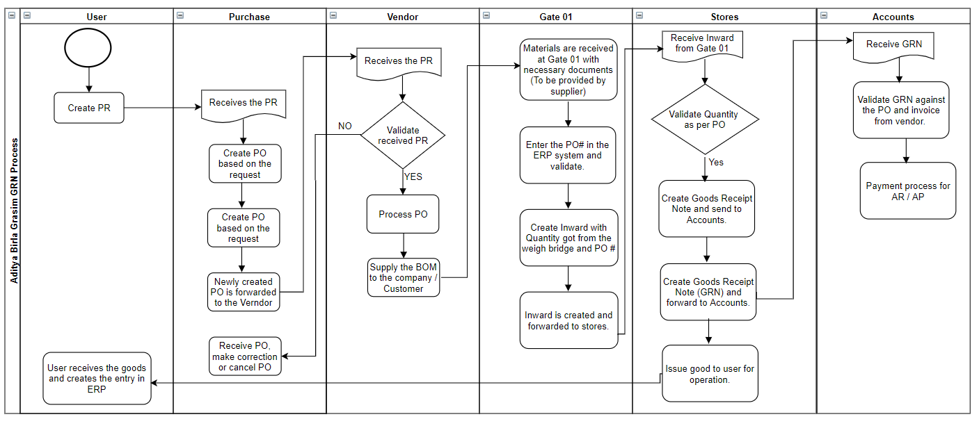

**Note:**

Zoom 170 % and above to see the image clearly.

**Process Steps:**

Invoice Process

Invoice process for Sulphur:

1. Open SAP.
2. Select SAP Grasim.
3. Enter the T-Code (MIR7).
4. Transaction dropdown should be <Invoice>, refer to the image below.

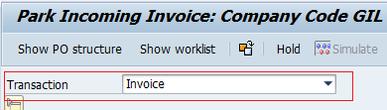

1. Select “Basic Data” tab, refer to the image below.

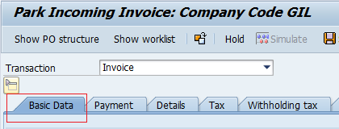

1. Enter <Invoice date> <Invoice #> <Amount>, refer to the image below.
2. Check mark in <Calculate Tax>, refer to the image below.
3. Enter plant code in <Bus Place/Sectn> field. (To be fetched automatically, TBD).

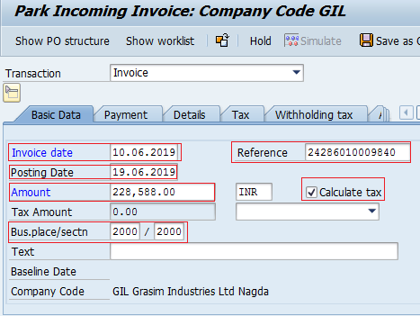

1. After entering all the details, check if there is any text displayed in <Balance> field, refer to the image below.

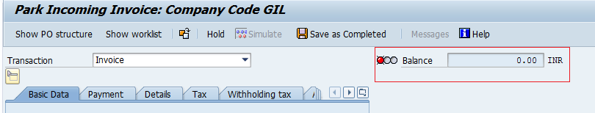

1. If incase any text is displayed, copy the text and put it in <Unpl.Del.CST> field in “Details” tab, refer to the image below.
2. Select the <Doc.Type>, Refer to exception section, refer to the image below.

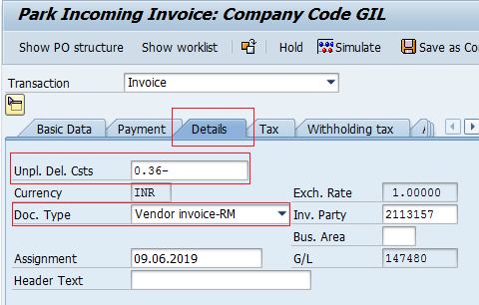

1. Navigate to “PO Reference” tab in the bottom of the screen, refer to the image below.

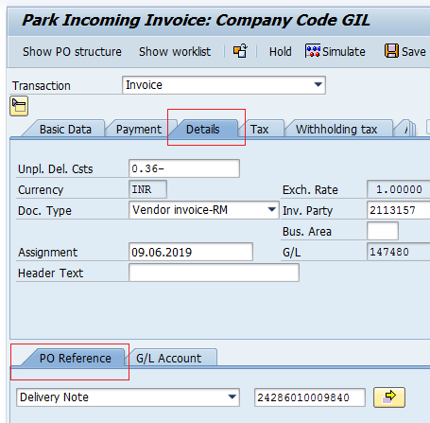

1. Select <Purchase Order/Scheduling Agreement> in the dropdown, If incase of reliance invoice <Delivery note> is to be selected.

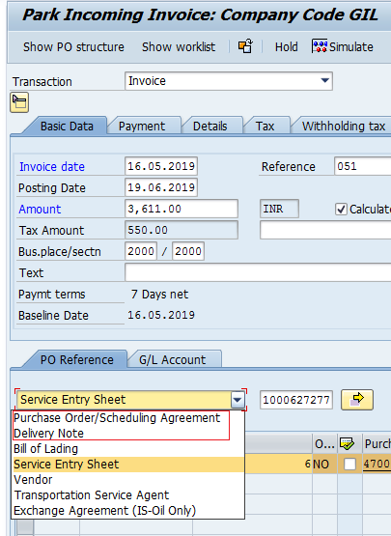

1. Pickup invoice # from the reference # field in “Basic Data” tab and enter it in the text field next to the dropdown.

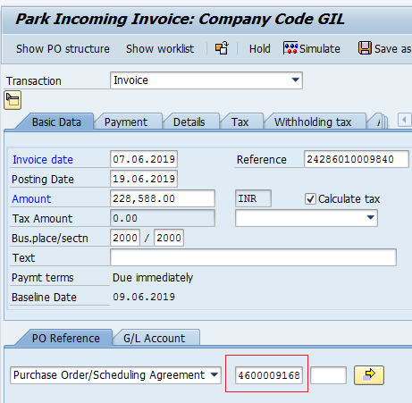

1. Select the document from the list which is matching, the amount and select save the document.

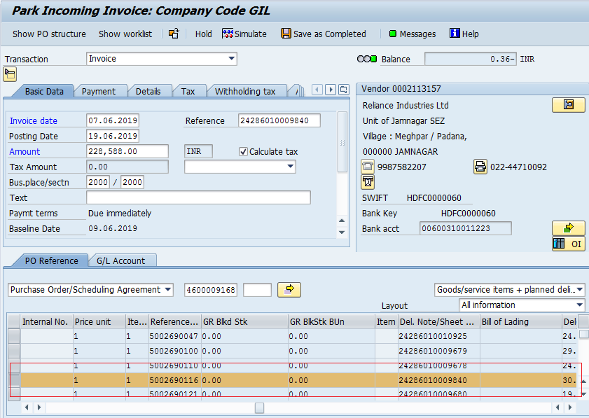

1. Document # will be generated in the bottom of the screen. Capture the number.

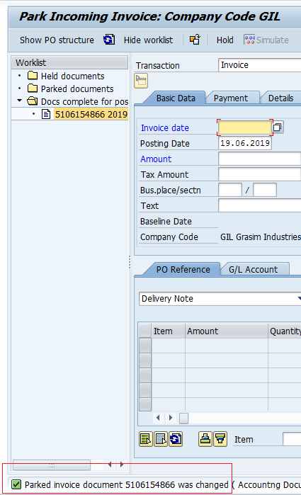

1. Append the captured number with the existing name and

Invoice process for Caustic

1. Follow the same steps as invoice process for Sulphur from step 3 – Step 9.
2. In the “PO Reference” tab select **Service entry sheet** and enter the <Entry sheet #> (to be got from scanned doc).

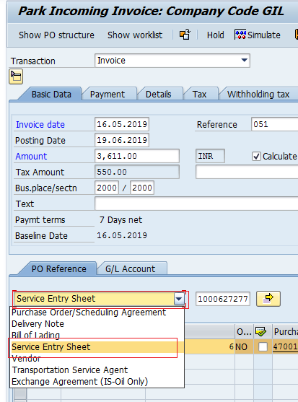

1. Copy the text in the <Advice Note> field in the scanned document and put it in <PO Text> field in “PO Reference” tab.

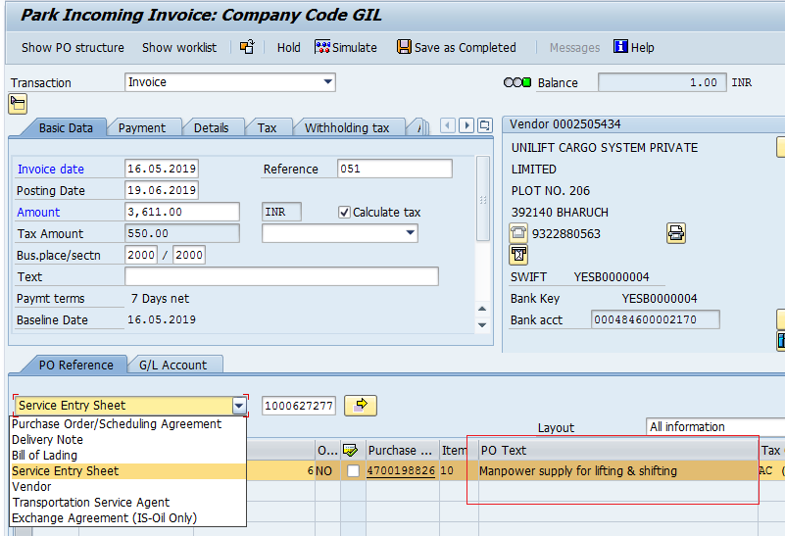

1. Navigate to “Withholding” tab and remove **PZ** text in all the records other than first row.

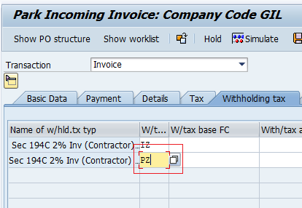

Business Exception:

* + If there is any difference in the quantity use <Park> option instead of saving.
  + Doc Type differs based on the vendor and type of item for which the invoice is generated.

Good Receipt Note process.

GRN – Sulphur

1. Open SAP
2. Select “SAP Grasim”
3. Enter respective T-code (ZINMM004 – Sulphur), (ZINMM004 – Caustic), (ZINMM005 - Steam Coal) Inward page will be displayed
4. Select <PO> from the dropdown in the Reference field.
5. Enter PO# in <In/Outward No> text field and press enter.

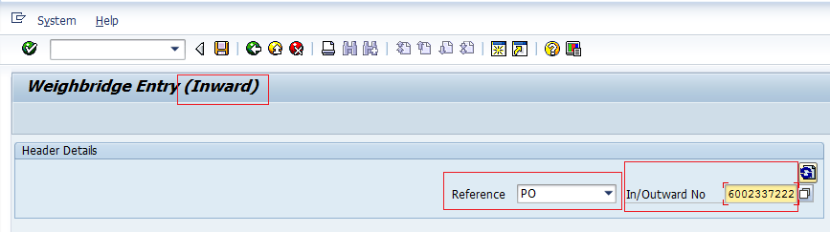

1. Enter the quantity in <Freight Qty> field (Qantity is chosen which is less between supplier weigh bridge quantity and Gate 01 weigh bridge quantity) and post the GR

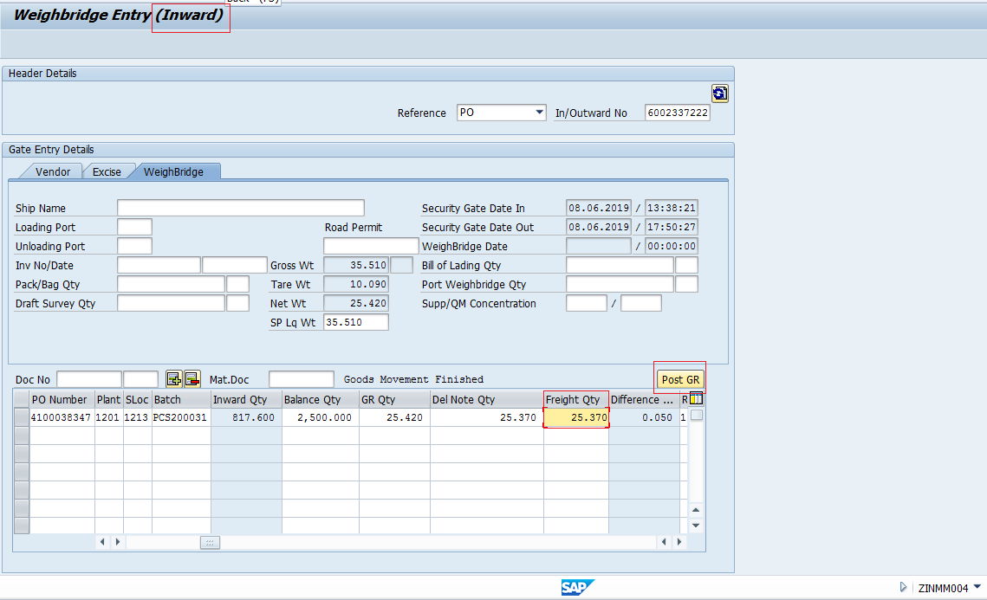

1. Enter T-code MIGO
2. Select <Goods Receipt> & <Purchase Order> in the dropdown.
3. Enter the PO# in the text field next to dropdown and press enter.

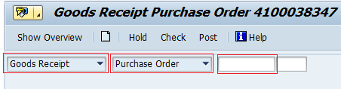

1. Select “General” tab enter the date in <Document Date> field (Invoice date) and <Posting Date> field (Inward date)
2. Enter the Deliver note # and Bill of landing # in the text field provided

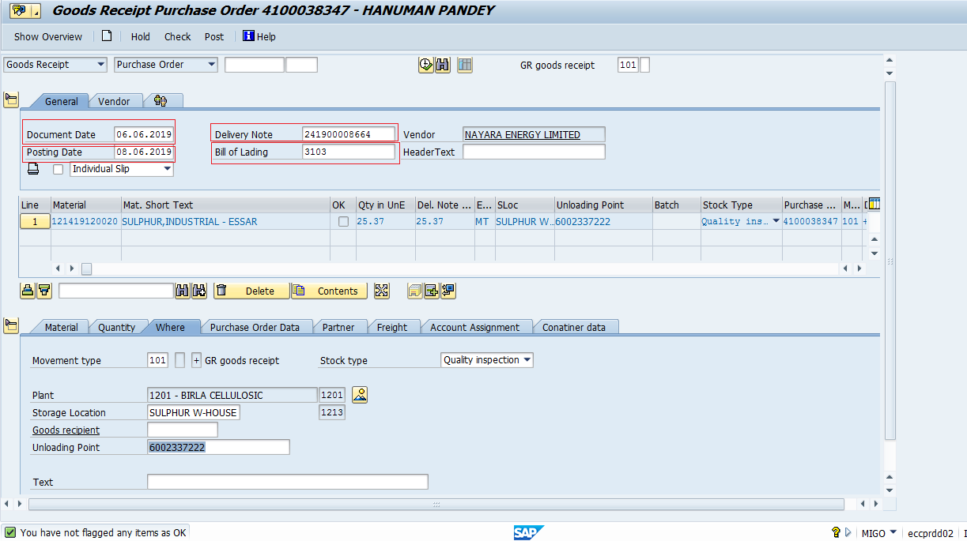

1. Select “Excise Duty” tab and select <No Excise Duty> from dropdown.

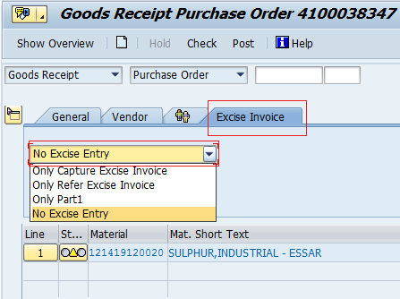

1. Select “Quantity” tab in the bottom of the screen.
2. Enter the quantity in <Qty in Unit of Entry>.

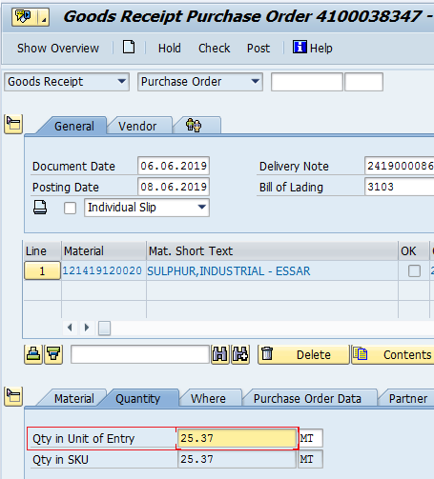

1. Enter <GR goods receipt> as 101.
2. Select “Where” tab in the bottom of the screen.
3. Enter the <unloading point>.

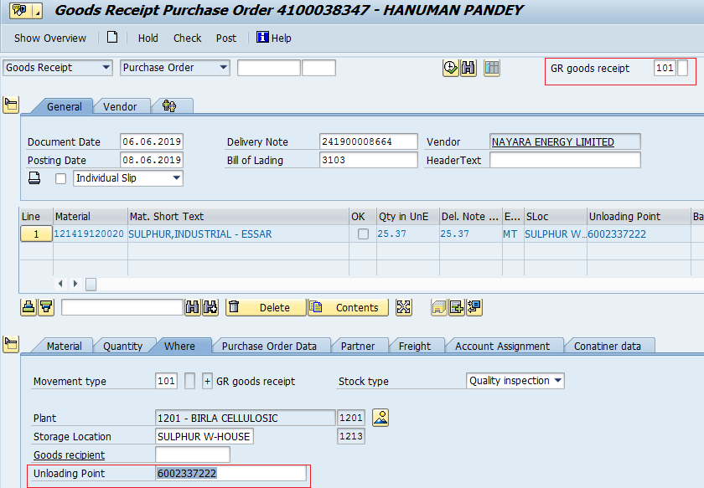

1. Post the document.
2. Materials Document # is generated and popup is displayed.

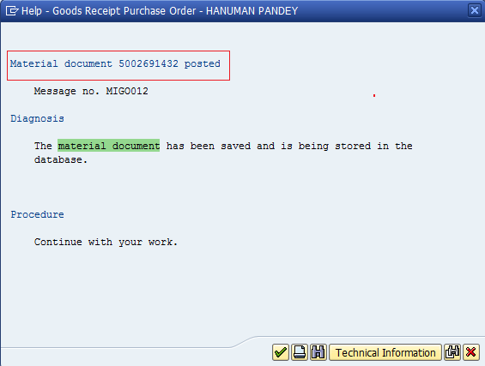

**Note:**

* + Inward date to be fetched from (ZINMM004) screen.
  + Invoice date to be got from scanned docs.
  + PO# to be got from the scanned docs.
  + Delivery note # (PO #) to be got from the scanned doc.
  + Bill Of Landing # to be got from scanned doc.
  + Enter Inward reference # in <unloading Point> field.
  + When the BOM is from Reliance and International Import

First MIRO needs to be created before following the rest of the process defined for GRN creation.

# To Be Business Process Flow

## 2.1. Scope

### Activities in scope

### 2.1.2 Activities out of scope

## 2.2 To Be process flow diagram

**Process Steps:**

### 2.2.1 Input Design and Process Stages

*[Explain the different input data that the robot will require and where robot should start with the process. Explain the different stages through which the data gets processed along with folder structure and intermediate files wherever applicable]*

*Folder structure can be explained with a diagram as below*

### File formats and Templates for Developer Reference

|  |  |  |
| --- | --- | --- |
| 1 | File 1 Listing sample | *<specify location or attach sample file>* |
| 2 | File 2 sample |  |
| 3 | File 3 sample |  |
| 4 |  |  |

### 2.2.2 Standardization in current process (if any)

*[List down any standardization requirements that have to be newly introduced in the process due to automation which does not exist or done differently earlier. E.g. Email format standardization]*

### 2.2.3 Output Design, Logs and Archive

*[Explain the different output that the robot will create and how the user should interpret and proceed with the output for further activities. Explain the output status report, process logs and exception logs format the robot will create and where to find them]*

### 2.2.4 Exception scenarios handling

|  |  |  |  |
| --- | --- | --- | --- |
| **#** | **Exception Name** | **Location / Step** | **Action to be taken** |
| 1 |  |  |  |
| 2 |  |  |  |
| 3 |  |  |  |
| 4 |  |  |  |
| 5 |  |  |  |
| 6 |  |  |  |

### 2.2.5 Process Breaks and Restarts

### 2.2.6 In scope application details

|  |  |  |  |  |
| --- | --- | --- | --- | --- |
| **#** | **Application Name & Version** | **App Type** | **Environment / Access method** | **Comments** |
| 1 | SAP | ERP | Sanbox | TBD |
| 2 |  |  |  |  |
| 3 |  |  |  |  |

# 

# 3. Solution Design – Technical Details

Details filled in by the developer reflect the actual information for the master project released for production.

|  |  |  |
| --- | --- | --- |
| # | Item | Details  *(Fill in with free text. If not applicable, mark the field as “n/a. No empty fields.)* |
| 1 | Master project name and version | TBD |
| 2 | Robot type  (specify if the process was automated for attended or unattended or mix) | TBD |
| 3 | Is Orchestrator used? (Yes/ No) | TBD |
| 4 | Scalable? (Yes/ No)  (can the process be run by multiple robots in parallel) | TBD |
| 5 | GIT Repository for project  (where the developed project is stored) | TBD |

## 3.1 Prerequisites for Development

* Development or testing environment will be provided for development.
* Development/testing environments are exact replicas of the production environment.
* Dedicated system and application access are given to developers with the adequate permissions.

## 3.2 Project Files (Workflows specific to project name)

Define below all the workflow files (.xaml files) used in the project, with the Input and Output data.

|  |  |  |  |
| --- | --- | --- | --- |
| **#** | **Workflow file name** | **Description** | **Reusable (Y/N)** |
| 1 |  |  |  |
| 2 |  |  |  |
| 3 |  |  |  |
| 4 |  |  |  |
| 5 |  |  |  |
| 6 |  |  |  |
| 7 |  |  |  |
| 8 |  |  |  |
| 9 |  |  |  |
| 10 |  |  |  |

*\*Add more rows to the table to include all the workflow file names. No fields should be left empty. Use “n/a” for the items that don`t apply to your project.*

## 3.3. Development

### 3.3.1 Screenshots for development (Key stroke level)

### Infrastructure/Access for environments

*Nothing specific*

Credential & Asset Management

Log on details (user IDs and passwords) should be stored under **Windows Credential Manager** or **UiPath Orchestrator Assets**.